Cornerstone Community Action Agency

Retired and Senior Volunteer Program

Volunteer Handbook



Lead with Experience

Brown, Coleman, Comanche, Eastland, and Runnels Counties

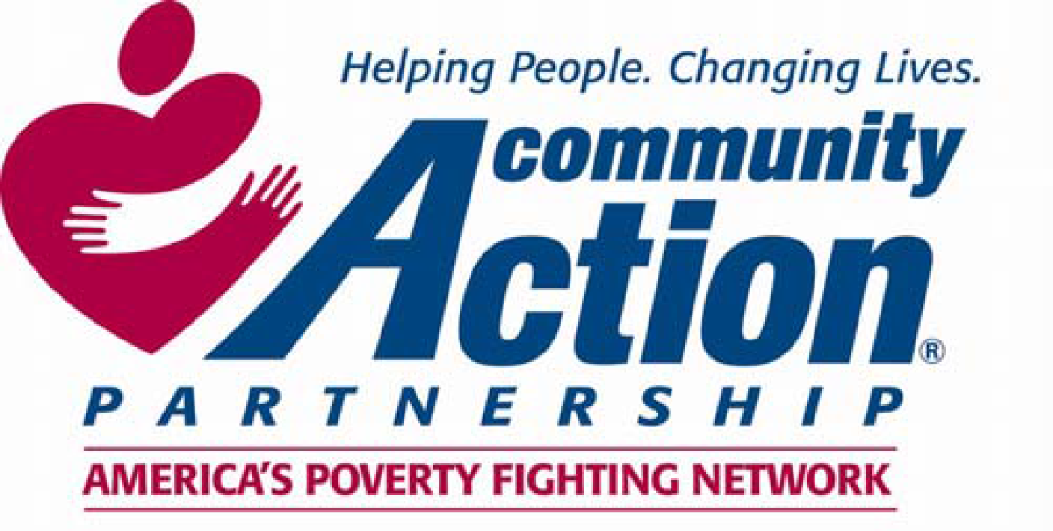
114 Needham Street
Coleman TX, 76834
325.625.4167
www.ctoinc.org

TABLE OF CONTENTS

Welcome to RSVP! 4
CCAA Mission, Vision, and Values 5
What is RSVP? 6
A brief history on RSVP 6
Who can be a CCAA RSVP volunteer? 8
what is an RSVP VOLUNTEER STATION? 8
HOW TO BECOME AN RSVP VOLUNTEER 9
BACKGROUND CHECKS 11
BENEFITS OF BECOMING AN RSVP VOLUNTEER 12
What can I Expect as a Volunteer? 13
volunteer Responsibilities 15
what activities are prohibited for a volunteer 20
RSVP volunteer inactivity, separation & Appeal process 20
cncs required information 22
Equal Volunteering Opportunity 23
Inclement Weather/Emergency closing 23
Whistleblower policy 23
Problem resolution policy 24
RSVP Supplemental Insurance reqts & summary of Coverage 25
Volunteer Information Update 27
Signature on RSVP Volunteer Forms 28
CCAA RSVP Contact Information 29
Receipt and Acknowledgement of Volunteer Handbook 31

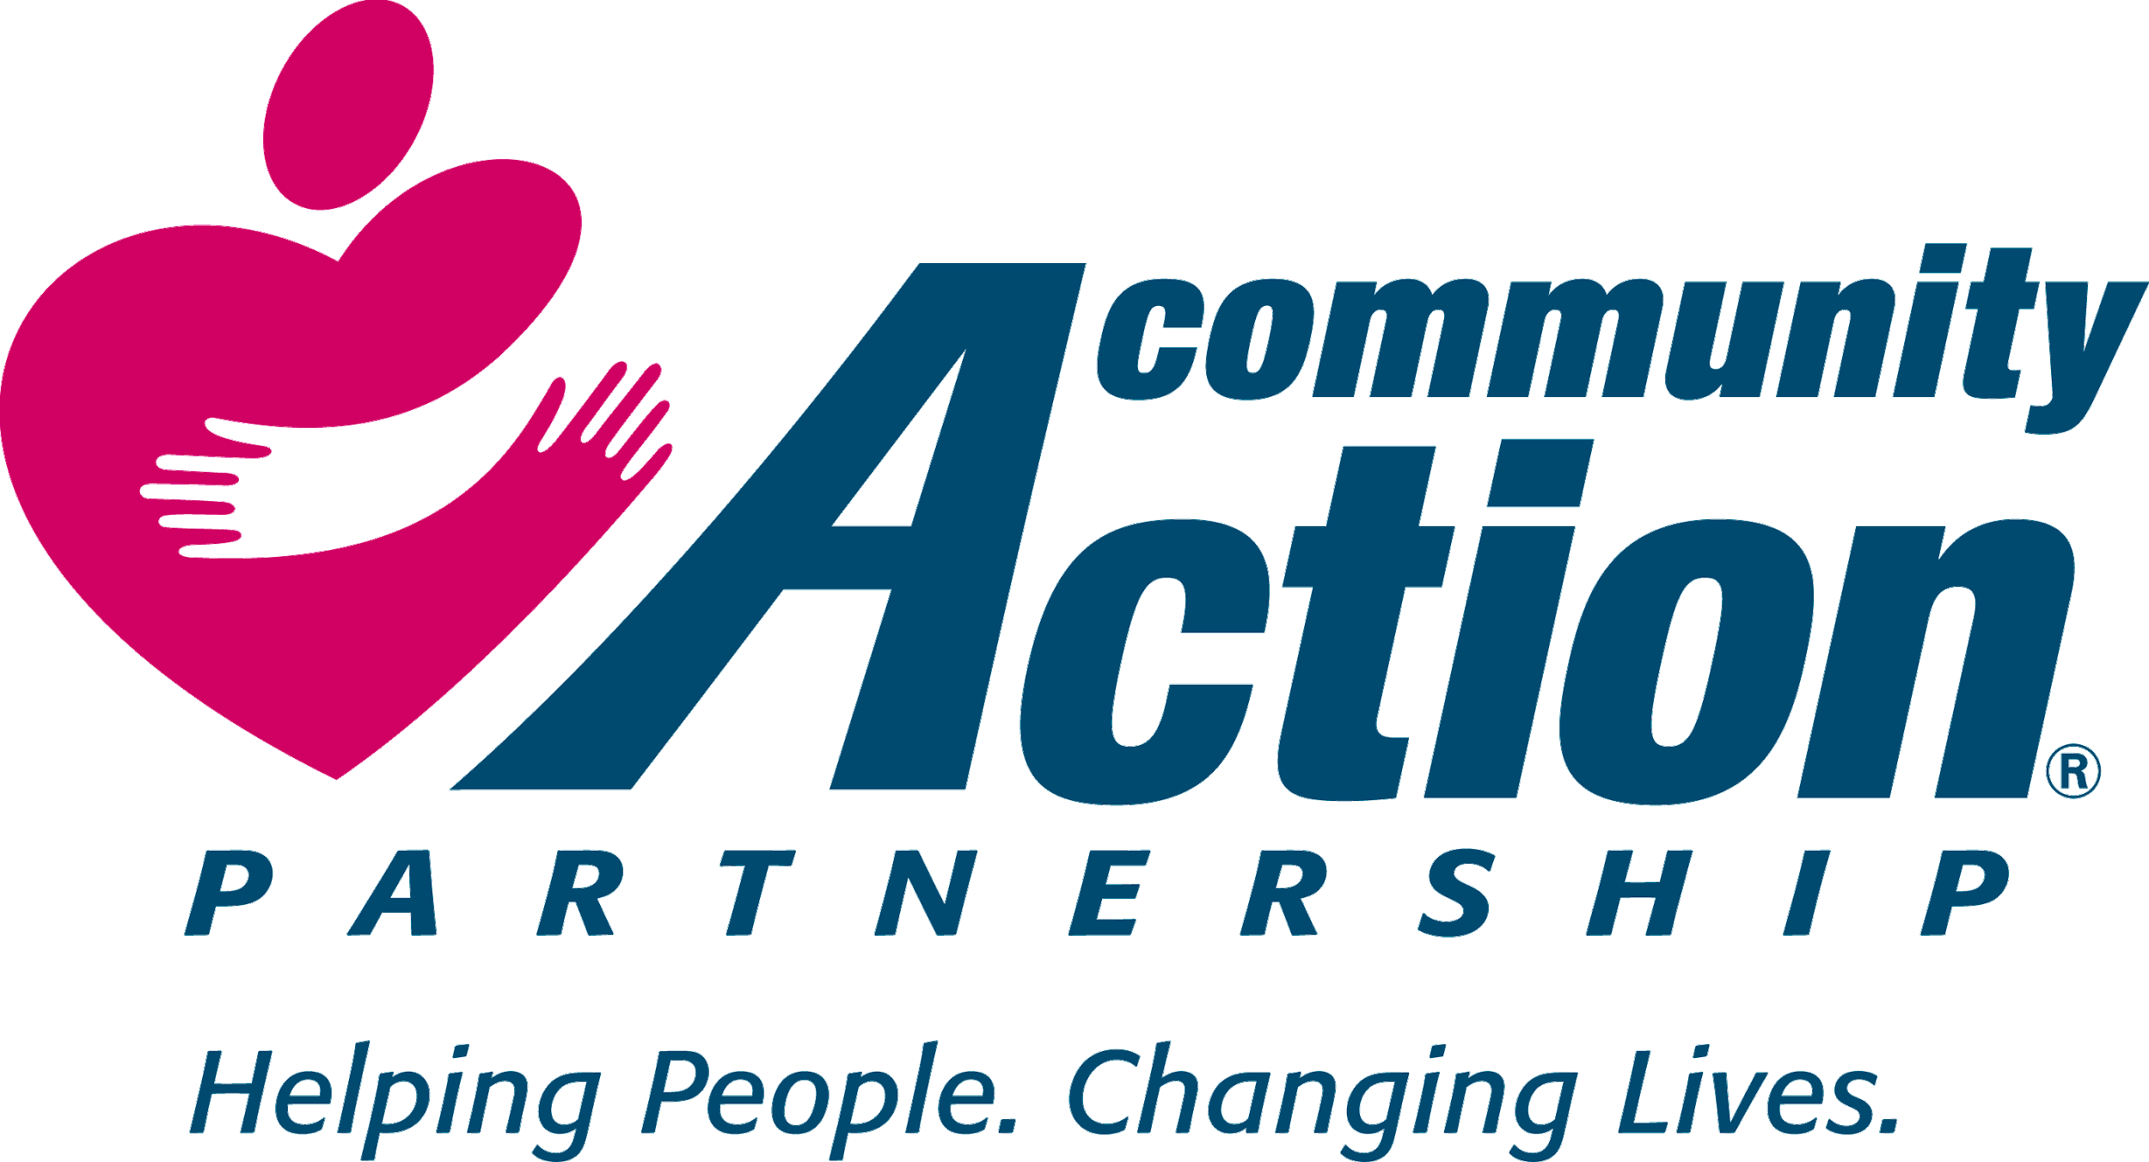
Cornerstone Community Action Agency
114 Needham Street
Coleman, Texas 76834
(325)625-4167 (325)625-3335 (fax)
Dear RSVP Volunteer,
It is a pleasure to welcome you to the RSVP program. Your volunteer service is an important contribution to your community, and I thank you for choosing to partner with RSVP.
The Volunteer Handbook will provide answers to questions you may have about the Retired and Senior Volunteer Program. It covers philosophy, policies and procedures as well as the responsibilities of staff, stations and volunteers. You are responsible for reading the handbook and adhering to the RSVP policies and procedures. Although no handbook can answer every question, we have attempted to cover major points of volunteering with us, and numerous topics that will help you to have an enjoyable experience as an RSVP volunteer. If you have questions regarding your volunteer experience, you are encouraged to discuss them with our RSVP Director.
If at any time, you desire a change in assignment or additional volunteer work, we will be happy to assist you. Our goal is to make sure you’re happy with your volunteer service.
Sincerely,
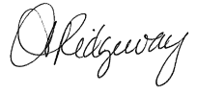
Mandy Ridgeway
Retired & Senior Volunteer Program Director
Vision Statement
To build thriving and self-sufficient communities by creating equal opportunities for all individuals and families.
Mission Statement
A Community in Action, Empowering People, Changing Lives, and Offering Hope to Achieve Self Sufficiency.
Values (Guiding Principles)

- Integrity. We conduct all business lawfully and with integrity.
- Compliance. We strive for 100% compliance.
- Honesty. We expect honesty among staff, governing boards, families, and the communities we serve.
- Respect. We treat others with dignity, respect, honesty, and sensitivity. We appreciate the value of diversity. Encourage and practice teamwork.
- Pride. We strive to instill pride in the character of each individual.
- Change. We embrace change. Envision what could be, challenge the status quo, and capitalize on growth opportunities.
- Customer Focus. Understand and develop relationships with customers to fully understand and satisfy their needs.
- Knowledge & Education. We believe knowledge and education is the foundation for a brighter individual.
- Transparency and Accountability. We practice transparency and accountability throughout all organizational practices.
- Fulfillment. Produce results that create value to realize your full potential and find fulfillment in your work.
What is RSVP?

Retired and Senior Volunteer Program (RSVP) was created for the dual purpose of engaging persons 55 and older in volunteer service to meet critical community needs; and to provide a high-quality experience that will enrich the lives of volunteers. RSVP recognizes and values the experience and wisdom of mature Americans as one of our nation’s most important natural resources. We believe that by volunteering, you are helping our community while staying active and healthy. We hope to make volunteering easy and rewarding.

RSVP is funded by Congress through the Corporation for National & Community Service (CNCS). Today there are more than 200,000 volunteers tackling tough issues in communities nationwide. In joining the program, you become part of a national movement of hundreds of thousands of volunteers striving to help their communities.

A Brief History of RSVP

In 1961, the White House Conference on Aging called attention to addressing the needs of retired persons in America. One of the outcomes of the Conference was the passage of Older Americas Act of 1965. The same year, the Community Service Society of New Your launched a pilot project on Staten Island named SERVE (Serve and Enrich Retirement by Volunteer Experience). This project was the precursor to the Retired Senior Volunteer Program (RSVP). The success of this project, which demonstrated beyond a doubt the value of the services of older volunteers, let to an amendment to the Older American Act, creating RSVP in 1969.

Since that time, RSVP has expanded throughout the United States. There are now well over 200,000 RSVP volunteers in cities all around the country giving more than 45 million hours of time in service to their communities. Authorized and funded by Congress, the program is administered by the Corporation for National and Community Service (CNCS) which monitors and advises local projects.

FOCUS: CNCS has developed 7 focus areas and directed its grantees to dedicate the majority of their time and energy in one or more of these areas which are:

Disaster Services

Economic Opportunity

Education

Environmental Stewardship

Healthy Futures

Veterans and Military Families

Who can be a CCAA RSVP Volunteer?
Anyone age 55 and older may become a volunteer. To be eligible for RSVP benefits, name badge, supplemental insurance coverage and recognition, you must fill out an RSVP Volunteer Enrollment form and any additional forms required by the RSVP Volunteer Station. You will receive an orientation and an information packet that includes a listing of current volunteer opportunities and job descriptions.
What is an RSVP Volunteer Station?
An RSVP Volunteer Station is an organization where an RSVP member volunteers. It must be a public agency, a non-profit organization or a proprietary health-care agency or organization. The RSVP Volunteer Station must sign a Memorandum of Understanding (MOU), which establishes the responsibilities of both RSVP and the RSVP Volunteer Station with respect to RSVP volunteers. By signing the MOU with CCAA RSVP, the RSVP Volunteer Station agrees to offer volunteers appropriate and specific volunteer assignments and to designate a coordinator who will serve as a contact person for both the volunteer and the RSVP office. The RSVP Volunteer Station agrees to explain all volunteer assignments to these volunteers and provide an orientation and training to the volunteers as necessary to perform their assignments.
We currently have several partnerships established with local agencies in our service area such as Meals on Wheels, Plus, Brownwood Area Community Garden, Volunteer Income Tax Assistance Program, Tenant-Based Rental Assistance Program, and the Coleman County Center for Senior Citizens.
How to become an RSVP Volunteer
- Enrollment- Contact RSVP by phone or in person to complete an RSVP enrollment form and set up an interview. Applications are also available at each of our volunteer stations.
- Interview- The Interview will be with the Volunteer and RSVP Program Director or the Volunteer Coordinator to discuss your interests, talents, sill and the kind of jobs you have had in the past, any past volunteer experience and the type of volunteer jobs you might like to perform, approximately how much time you would like to spend volunteering, and any other requirements you may have (e.g. location preference, or whether or not you are willing to travel).
  - Once the interview is completed and it is determined that you would like to volunteer at a station other than CCAA, the director will contact the RSVP Volunteer Station and forward the completed enrollment form for review; the RSVP Volunteer Station Coordinator will set up an interview with you and finalize your volunteer status.
  - If you decide to volunteer either as an RSVP volunteer or a non-RSVP volunteer, the director will forward the completed enrollment form to the assigned program director for an interview, orientation and training.
- Orientation- Orientation will introduce the volunteer to RSVP, the sponsor and CNCS, address prohibited activities (including the Hatch Act; https://osc.gov/Pages/HatchAct.aspx) provide information on project policies, time sheets, appeal procedures, insurance, job descriptions and other administrative details. It will acquaint volunteers with project, volunteer station, sponsor staff, and other RSVP volunteers. It will give RSVP volunteers the opportunity to visit and become acquainted with their volunteer stations, provide new RSVP volunteers with information about available community services related to their assignment, and where appropriate, provide training on working with vulnerable populations.

If you know anyone who would like to volunteer but they don’t know where to start or would like some help in finding opportunities, please have them contact us at (325) 625-4167.

Background Checks

To assist the process of appropriate volunteer placement, RSVP Volunteer Stations may access public criminal records for any registered volunteer. A volunteer who works with vulnerable populations: those under 18 years of age, those over 60 years of age and those who are disabled, may be required to have a criminal background check by the station site. If required by your site, you will not be allowed to work until it’s cleared.

Benefits to Becoming a Volunteer

Personalized Assistance- RSVP staff will work with you to identify a volunteer opportunity that will meet your individual needs. We will match your skills, interests, schedule, and geographic availability with a volunteer position that is right for you. We will continue to be available to provide ongoing information and support as your volunteer needs evolve.

Be Part of a National Movement- Adults 55 years and older are giving thousands of hours daily to positively impact the community they live in. Your hours will be counted with those of your peers to demonstrate to policy makers and the community the impact of senior volunteerism on a local and national level. Help send the message that mature adults are making meaningful contributions, solving problems and bringing communities together.

Training Opportunities- Learn new skills in areas related to your volunteer service and other areas of interest to you.

Community Involvement- Through volunteering you will learn more about your communities, service providers, and other non-profit agencies.

Volunteer recognition- RSVP celebrates your accomplishments and honors the work that you do. This takes a variety of forms, including special events, trainings, and opportunities offered to RSVP members.

Supplemental Insurance- As an RSVP member you will be covered by supplemental insurance (volunteer liability, excess automobile liability if appropriate, and accident) when you volunteer. In the unfortunate event that something happens to you while volunteering, or while traveling to and from your volunteer position, the insurance will help cover deductions and out-of-pocket expenses related to the accident (see page 24 for details on Supplemental Insurance).

Travel Reimbursement- RSVP volunteers may receive assistance with the cost of transportation to and from volunteer assignments and official project activities, including orientation, training and recognition events. Reimbursement funds are not guaranteed and only available when grant funds allow.

What can I expect as a Volunteer?

As a volunteer, you can expect to:

Receive a clear and specific job description.

Be given assignments according to your skill, interests, availability and training.

Be given appropriate formal and informal expressions of appreciation and recognition.

Received orientation, training and supervision for the volunteer assignment you accept.

Have your time used well through planning and coordination.

Be able to discuss any problems with your supervisor, and receive prompt attention to any concerns.

That your individual rights will be respected and that all volunteers will be treated with courtesy and consideration.

Have appropriate work space including consideration of physical disabilities.

Work in an environment with a spirit of friendliness and cooperation.

What is expected from our Volunteers?

Your first responsibility is to know your duties and perform them in a prompt, correct, and pleasant manner.

You are expected to cooperate with your supervisor(s) and fellow volunteers while also maintaining a good team attitude. Your interactions with all of the groups, as well as the public, will affect the success of your volunteer experience.

Consequently, whatever your position, you have an important assignment: to perform every task to the very best of your ability. The result will be greater personal satisfaction for you and the services delivered will be improved and enhanced.

Volunteer Responsibilities

Volunteer Policies and Procedures

Absence and Tardiness

Volunteers are expected to be reliable in the performance of their volunteer duties. Volunteer attendance is expected to be dependable and punctual.

If you are unable to report to volunteer, or if you will arrive late, please contact your volunteer station supervisor as soon as possible. Please give the supervisor as much time as possible to arrange for someone to cover your position.

Date of Service and Enrollment

Your date of enrollment is your official start date. The date you start your intent to resign is your official ending date. When you enroll you will be asked to verify your age. Active status begins when service time is recorded.

If you have a photo ID we may copy it for the record. Your file must be updated annually to assure the information remains correct.

Timesheets

Timesheets are required of all volunteers.

As a federally funded program, we are required to maintain records of the hours of service given by RSVP volunteers. Tracking volunteer hours also helps us to tell the story of how important volunteers are and how our society thrives on the knowledge and experience of persons 55 and older. Your hours give a description of where you, the volunteer, are being most helpful in strengthening our local community.

Volunteer hours are due to the RSVP director by the 5th of each month. Volunteers may report their own hours on RSVP timesheet to be signed by the volunteer, site supervisor and RSVP Director. A report from the volunteer station with all volunteer signing in or with a listing volunteer name, hours, and assignment is also acceptable so long as it is supported by a signature of the station director, supervisor/coordinator, or their identified designee.

Confidential Information

Your volunteer service assumes an obligation to maintain confidentiality. Volunteers are responsible for maintaining the confidentiality of all proprietary or privileged information to which they are exposed while serving as a volunteer.

As a volunteer, you may be privy to information that is confidential in nature. Such information cannot be shared with your family, friends, or acquaintances.

Volunteers may be asked by their volunteer station to sign a confidentiality agreement. Compliance with that agreement may be a condition of being able to volunteer at that station.

All Personally Identifiable Information (PII) will be protected.

RSVP Volunteer Code of Conduct

While volunteering, you as a volunteer must comply with the guidelines for staff and/or volunteers. This includes requirements for training, attendance, dress code, or any other guidelines established by the volunteer station.

Any concerns you may have must be first taken to the volunteer coordinator. If concerns are not resolved, please contact the RSVP Program Director at 325-625-4167.

At all times you must be appropriate for the tasks that you are performing so that you can complete your job safely. Should medical, physical, or other conditions change at any time, it is your responsibility to inform your site supervisor and the RSVP office so that appropriate changes can be made with regard to your volunteer activities.

The use of illegal drugs or alcohol, or being under the influence of same, while performing hours of service is strictly prohibited and shall be cause for termination of all your volunteer placements.

Report Accidents

You must report any accidents, even if you do not feel you need medical attention at the time. In case of an accident, notify the RSVP office at (325)625-4167 within 5 business days. Claim forms will be sent to you to be completed. Completed forms must be returned to the RSVP office.

What Activities are prohibited for a Volunteer?

Due to federal grant guidelines, RSVP Volunteers cannot perform the following activities as part of their RSVP service:

Give religious instruction, conduct worship services, or engage in any form of proselytizing.

Participate in any activity that may be construed to influence the outcome of any election or engage in voter registration or lobbying activity.

Perform activities which would otherwise be performed by an employee or result in the displacement of an employee.

Receive a tip or fee for service for service recipients, their legal guardian, or their family or friend.

RSVP Volunteer Inactivity, Separation & Appeal Process

RSVP or the Volunteer Station may separate a volunteer from the program for cause, including but not limited to the following reasons:

Extensive or unauthorized absences

Misconduct

Inability to perform assignments or accept supervision

Unsatisfactory performance

Breach of confidentiality

Behavior deemed inappropriate by volunteer station

Willful violation of security or safety rules, or failure to observe safety rules; failure to wear required safety equipment

Being intoxicated or under the influence of controlled substances while volunteering

Unauthorized possession of dangerous or illegal firearms

Theft of property

Threatening, intimidating or coercing fellow volunteers, the public, staff or volunteer station staff

Dishonesty, willful falsification, or misrepresentation on your volunteer application or other volunteer records

Separation may also be based on termination of volunteer assignment or when the volunteer assignment is no longer meaningful or satisfying to the RSVP volunteer.

Any volunteer who is terminated is entitled to an appeal. Refer to the Problem Resolution Policy (page 23).

CNCS Required Information

As an RSVP volunteer, it is our responsibility to make you aware of the following information:

Neither the grantee nor any volunteer station will request or receive compensation from beneficiaries of Senior Corps volunteers.

Any volunteer station may provide financial support of the Senior Corps project, but it is not a precondition for that station to obtain volunteer service.

A Senior Corps volunteer does not receive a fee for service from service recipients, their legal guardian, or members of their family, or friends.

Grant funds are not used to finance labor or anti-labor organizations or related activity.

Equal Volunteering Opportunity

Cornerstone Community Action Agency shall not discriminate against a RSVP volunteer on the basis of race, color, national origin, sex, age, religion, or political affiliation, or on the basis of disability, fi the volunteer with a disability is qualified to serve. All Volunteer Stations agree to the same terms as stated in their Memorandum of Understanding.

Inclement Weather/Emergency Closing

Each volunteer station will provide volunteers with their inclement weather/emergency closing policy.

Whistleblower Policy

In keeping with Cornerstone Community Action Agency’s policy of maintaining the highest standards of conduct and ethics, CCAA will investigate complaints of suspected fraudulent or dishonest use or misuse of its resources or property by staff, board members, consultants, volunteers, or clients to maintain the highest standards of service, CCAA will also investigate complaints concerning its programs and services. Refer to Whistleblower and Complaint Resolution Policy.

Problem Resolution Policy

If a situation occurs when a volunteer believes that a condition of volunteer placement, or a decision affecting them is unjust or inequitable, they are encourage to make use of the following steps.

The complaint or issue will need to be presented in writing and clearly identify the basis for the complaint and contain the following information: the specific conflict, the date the action or incident occurred, the reasons why the volunteer feels that the action was unjustified or unfair, plus any specific policy which was violated, and how this affected the volunteer and the corrective action desired.

All grievances should be presented to the RSVP Director within 14 calendar days after an incident occurs. The individual and Director should attempt to address the problem through discussion. If the problem involves the Director or the Director cannot resolve the issue, the volunteer should proceed to the Executive Director.

Problem should be presented to Executive Director within 14 calendar days. The Executive Director will review and consider the problem. The Executive Director will inform the individual of the decision within 14 calendar days. The Executive Director has full authority to make any adjustment deemed appropriate to resolve the problem.

RSVP Supplemental Insurance Requirements

We are required to provide accident, volunteer liability, and, when appropriate, excess automobile liability insurance. The minimum levels of this insurance are specified by the Corporation, and may be subject to change from time to time.

The insurance must be in excess of and noncontributing to any other valid and collectible insurance the volunteer have. In other words, the accident and excess automobile liability coverage are intended to provide higher levels of insurance for volunteers, starting where other insurance coverage for them stops. This is excess, not primary insurance.

Summary of Coverages

Excess Accidental Medical Coverage- Excess accidental medical coverage will pay up to $50,000 for medical treatment, hospitalization and licensed nursing care required as the result of a covered accident. The insurance applies during travel between volunteer home and place of assignment, during volunteer service, during meal periods while serving as a volunteer, and while attending project-sponsored activities, such as recognition activities, orientation, and Community Advisory Group meetings.

Excess Volunteer Liability Insurance- All registered volunteers (collectively) of an organization are provided with excess volunteer liability insurance at a limit of $1,000,000 per occurrence (subject to an annual aggregate for each named organization). This policy provides protection if you are liable for bodily injury or property damage arising out of the performance of your duties during your volunteer assignment. This coverage is in excess of and noncontributing with any other valid and collectible insurance you may have.

Excess Automobile Liability Insurance-This coverage provides an extra layer of protection for you as a registered volunteer driver while performing your duties. This insurance applies only after your own insurance is exhausted, or the policy’s retention has been exceeded. This coverage protects you for bodily injury or property damage claims arising out of the operation of your own vehicle during your volunteer assignment. It is important to remember that you must maintain your own auto liability coverage at least equal to the state-required minimums. Also, please remember that this coverage does not apply to any damage to your vehicle. Note: Some exclusions may apply.

Volunteer Information Update

RSVP’s federal funding regulations require that RSVP volunteers complete a Volunteer Information Update form once a year. This form allows us to verify relevant information that we maintain on volunteers such as address, phone number, primary means of transportation to volunteer activities, valid driver’s license number and expiration date, emergency contact, beneficiary for Accident Insurance, and that you carry your personal Vehicle the State of Texas required minimum insurance coverage for Personal Liability/property damage. If at any time during the year contact information changes, please notify RSVP staff.

Signature on RSVP Volunteer Forms

All volunteer forms, including those requiring signature, can be submitted in person, by mail, fax, email, or any other electronic/digital means.

Advisory Council

The Advisory Council is a council compromised of community representatives and volunteers whose purpose is to advise and assist the RSVP Director and staff in the operation of the program. Members are sought to share knowledge of local resources, help staff develop policy and procedures that best promote senior volunteers in the community, help evaluate the effectiveness of our efforts and educate the community about the service of our members.

Cornerstone Community Action Agency

Retired & Senior Volunteer Program

Contact Information:
114 Needham Street
Coleman, TX 76834
Phone: 325-625-4167
Fax: 325-625-3335


Mandy Ridgeway, RSVP Director
HYPERLINK "mailto:amanda.ridgeway@ctoinc.org" amanda.ridgeway@ctoinc.org

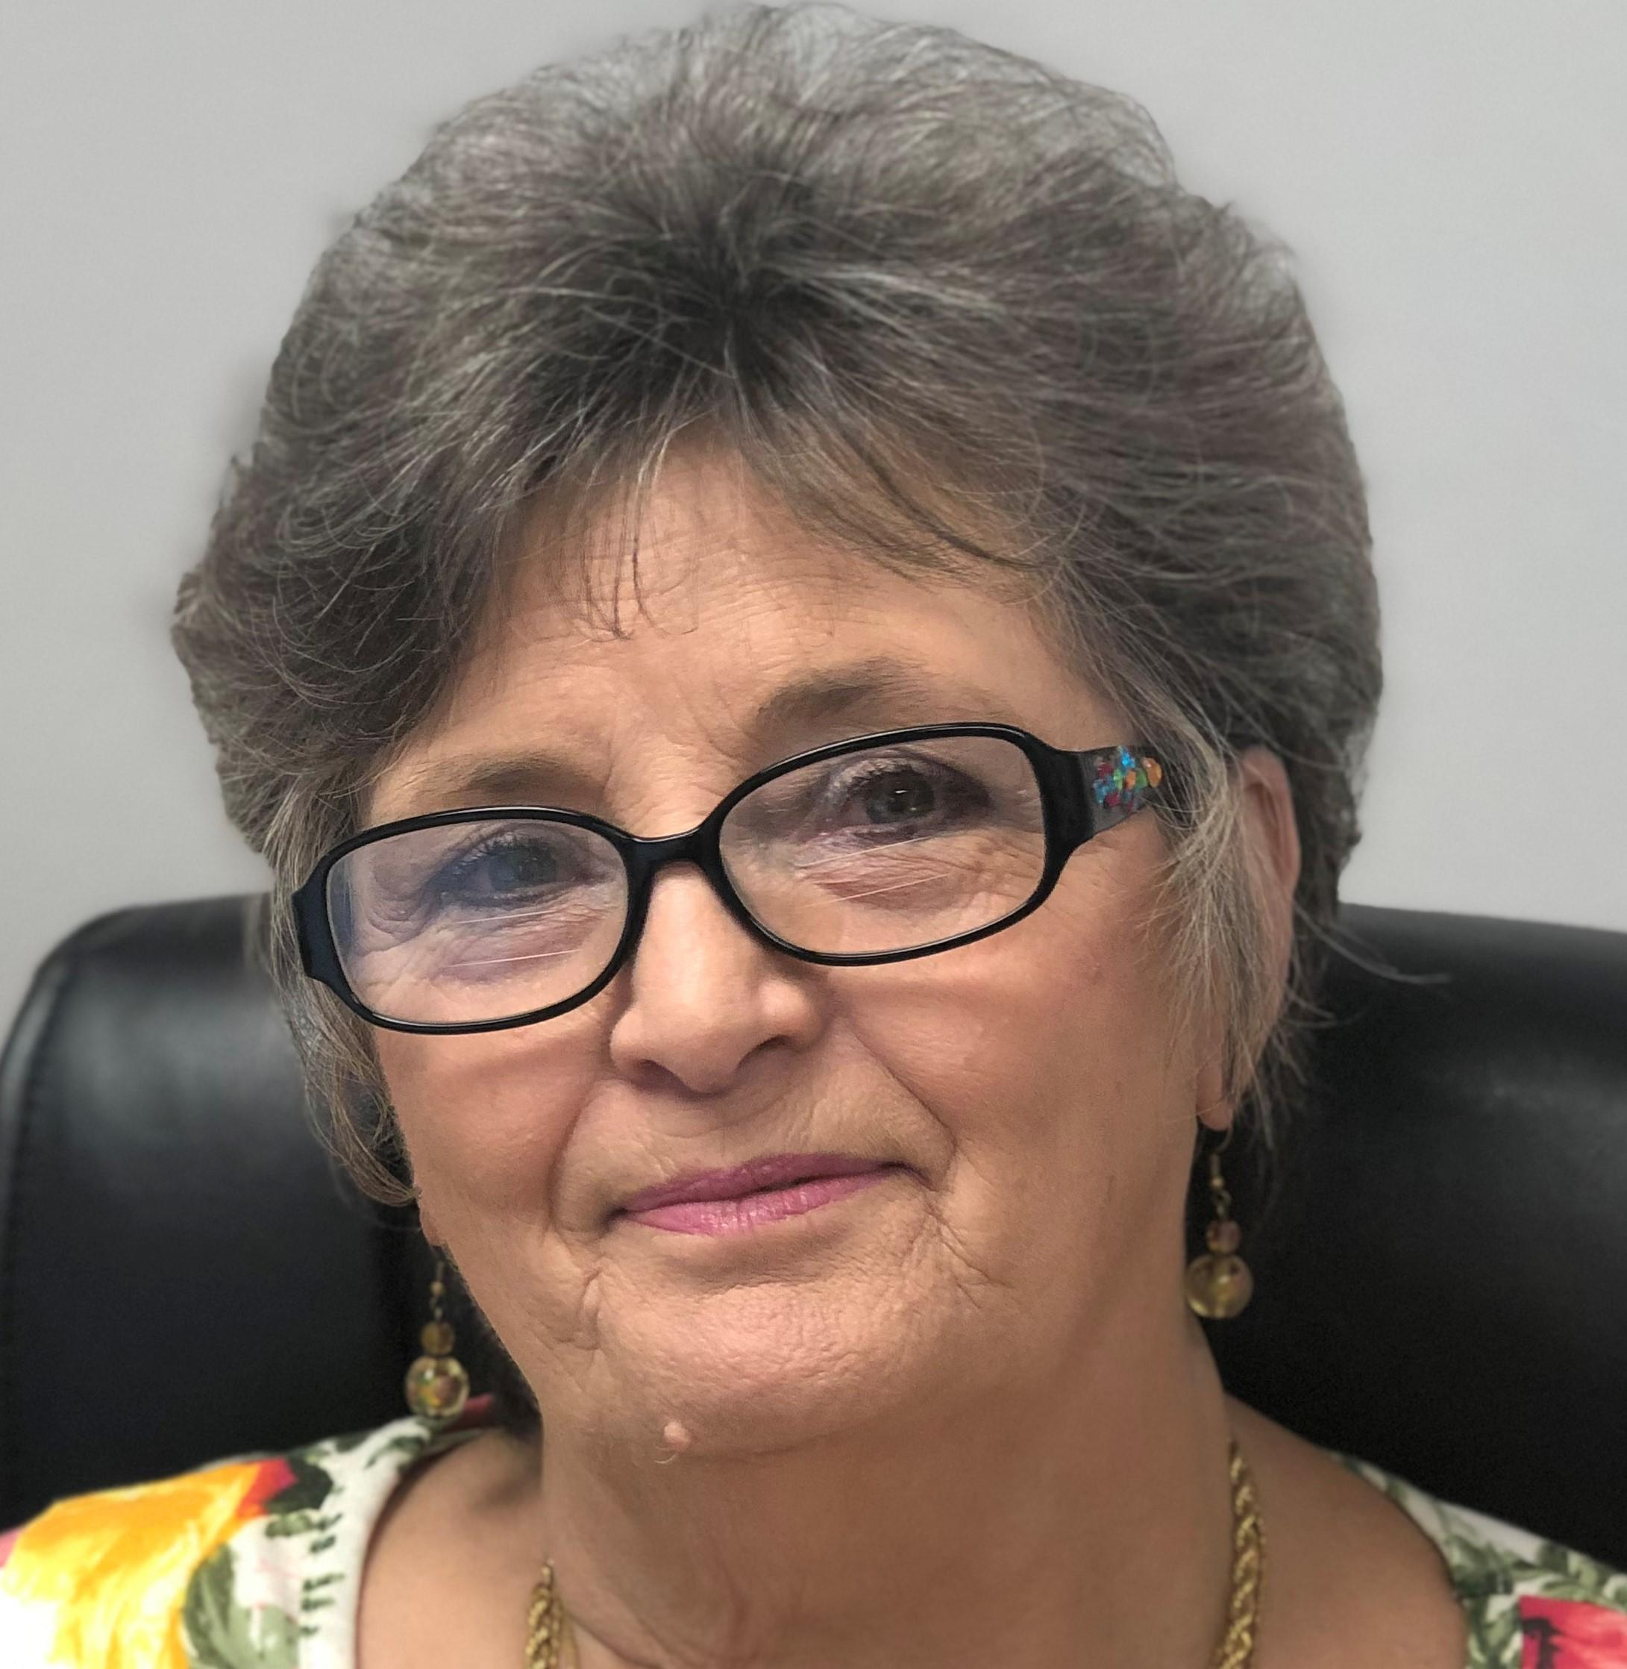
Willena Benson, RSVP Coordinator
HYPERLINK "mailto:wbenson@ctoinc.org" wbenson@ctoinc.org

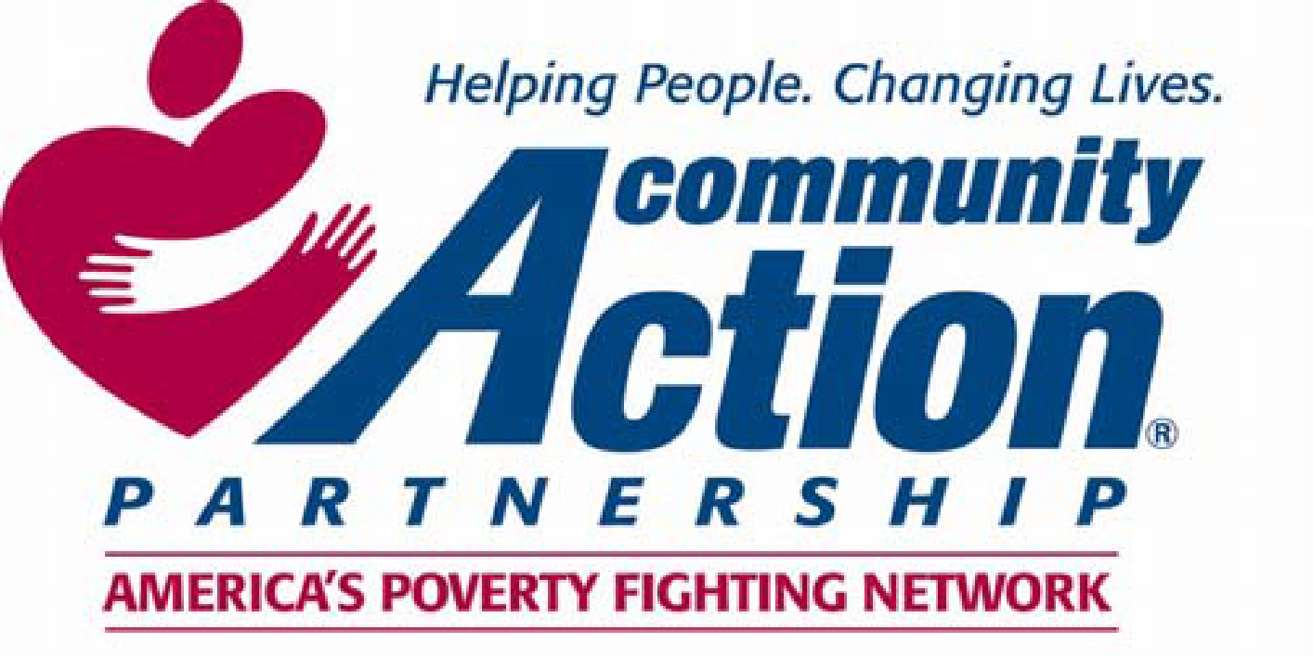

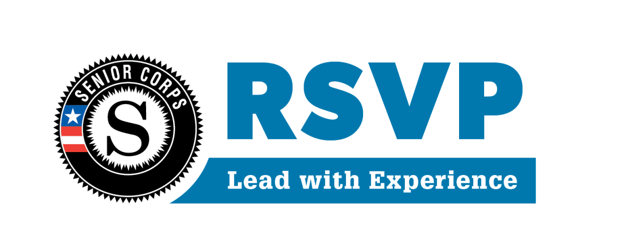
✂

Receipt and Acknowledgement of Volunteer Handbook

The Volunteer Handbook is an important document intended to help you become acquainted with RSVP. This handbook will serve as a guide to your service in your community. We hope that you have found this handbook helpful and encourage you to contact the RSVP office with questions and concerns. We appreciate your commitment to volunteer and hope that it provides you with a quality experience that will enrich your life and the lives of those you serve. Please read the following statement and sign below to indicate your receipt and acknowledgement of the CCAA RSVP Volunteer Handbook.

I have received a copy of the CCAA RSVP Volunteer Handbook. I understand the policies, rules, and benefits described within it are subject to change at the discretion of CCAA RSVP at any time.

I further understand that my volunteer service is terminable at will, either by me or the CCAA RSVP program, regardless of the length of my volunteer service.

I am aware that during the course of my volunteering, confidential information may be made available to me. I understand information must be held in the strictest confidence for the protection of me and those that I serve.

I understand that my signature below indicates that I have received a copy of the CCAA RSVP handbook for volunteers and have read and understand the above statements.

________________________________________ ___________

Volunteer Signature Date

